M 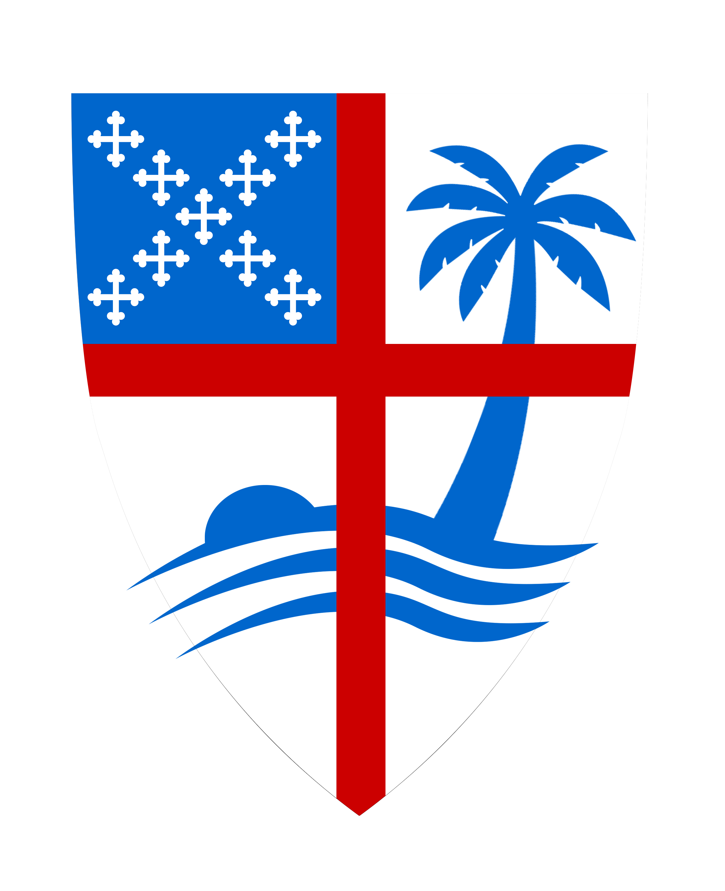 |  | Confirmation Class 2022  Session 3  Intro, Song, Evening Prayer  A brief history of the Book of Common Prayer.  WORSHIP IN THE EPISCOPAL CHURCH
Do we really need a book and a liturgy to worship?  The BCP helps us to keep the main thing the main thing, and the main thing is the worship of God. The BCP helps ensure that our church will not be hijacked by polarizing ideologies. The people of the church are not Democrats or Republicans or whatever ideological label that we divide over; no, we are brothers and sisters in Christ. In times of division, the BCP helps us to understand that we have something in common and that we have a lot more in common than we can ever have in conflict.  The liturgy has the same effect. It draws us together, It gives us a blueprint to be able to worship in a way that Honors God and recognizes our differences. |  | The structure leads us to deeper worship with Christ.  - The Ordo  - The Ordo is a calendar that provides direction for the liturgies of the day. It is also followed by Catholics, Lutherans, and Methodists to a lesser degree  - Helps us stay consistent  - The Liturgy of the Word  - The readings come from the Lectionary which Is done in a three-year cycle  - The liturgy of the table  - We remember When Jesus Instituted the act of Communion  - OTHER CEREMONIAL ACTS AND THEIR MEANING  - Colors  - Green, White, Red, purple, Or Dark Blue and Black  - Sign of the Cross, see attached page

