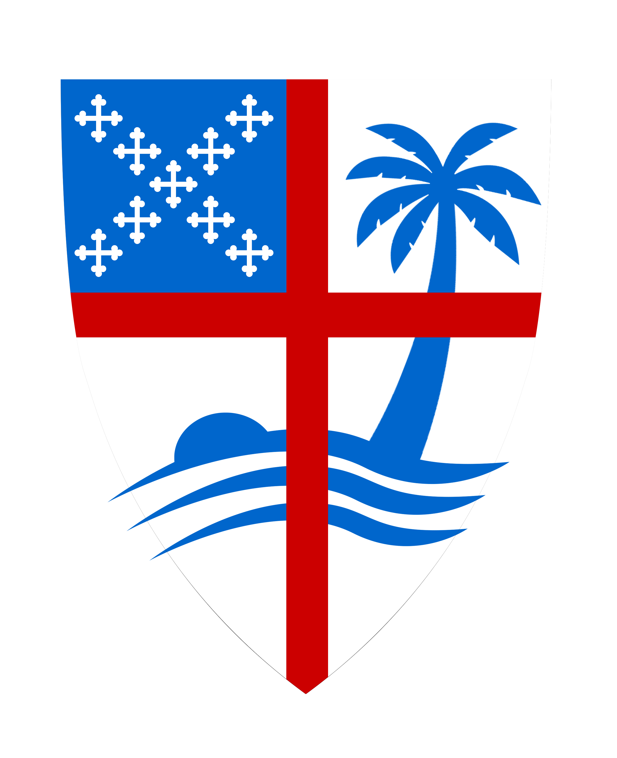 |  | Confirmation Class 2022  Session 2  Intro, Song, Evening Prayer  History Of the A.M.E  Church Structure and polity.
Do we really need a Denomination?  Sometimes, people say they “have no use for ‘organized religion.’” The correct punch line is, “Oh, then you’ll love The Episcopal Church!” Our democratic elements often make us look rather unorganized, but as a denomination, we do have structures within which we operate, and they can seem confusing.  Paul reminds the Corinthian church that he preached to them the pure, unadulterated Gospel. The Gospel is of first importance to the Church (1 Corinthians 15:3-5).  ³ For I handed on to you as of first importance what I, in turn, had received: that Christ died for our sins in accordance with the scriptures, ⁴ and that he was buried, and that he was raised on the third day in accordance with the scriptures, ⁵ and that he appeared to Cephas, then to the twelve. |  | Structure helps us peach the message of Jesus.  Opponents of denominations will argue that Paul is calling the Church to unite around the Gospel and forsake all other creeds and confessions. (“I’m not an Episcopalian, I’m simply a Christian.” After all, denominations focus on the secondary issues when what we need to focus on is the primary issue: the Gospel of Christ.  But rather than explicitly forbidding ecclesiastical denominations (a concept that didn’t even exist in the early church), Paul is reminding one local congregation in central Greece to focus on one thing as of first importance. He doesn’t say that other issues are not important. But he is reminding them of the overshadowing primacy of the Gospel.  Church Structure  The heart of the Episcopal Church is the Diocese. We are, after all, the Episcopal Church: not “Catholic” with a worldwide government; not “Presbyterian” with district rule by Presbyters (elder-level clergy); not Congregational with purely local autonomy.  The Presiding Bishop  General Convention  House of Deputies-  House of Bishops  Diocese  Parish

